**Software Requirement Specification**

**For**

**Health-Insurance-Prediction-System**

Table of Contents

1.1 Introduction 1

1.2 Scope 1

1.3 Overview 1

2.1 User profile: 1 2

2.2 User profile: 2 2

3.1 List of Functional requirement 3

3.1.1 Functional requirement: Customer 3

3.1.2 Functional requirement: Manager 3

4.1 UI/UX Design: Customer 4

4.2 UI/UX Design: Manager 5

5.1 Storyboard Customer 6

5.1.1 Select Location 6

5.1.2 Select Policy 6

5.2 Storyboard Manager 7

5.2.1 Log In 7

5.2.2 View record 8

5.3. Summary 8

# 1.1 Introduction

In traditional system a client has to move to an insurance branch in order to get an appointment. There is no guarantee that the client will get an appointment in his/her desired date as that date may already be booked. Again, different operations such as-recording client’s diagnosis information, keeping track of details etc. are done manually either by the operational staff of the bank or the client her/himself. There is no doubt that in this system a lot of papers are needed to be handled. Managers have to remember various insurance available for diagnosis and sometimes miss better alternatives as they can’t remember them at that time. Along with this the clients sometimes lose their previous prescriptions leading to a mistreatment. This age-old system is also very much time consuming and eventually lessen the quality of service

# 1.2 Scope

* HIS product is basically a prediction app which will allow customers to order Insurance using their Device.
* HIS can be used for any Insurance or Bank from where customer can order Policy from any Location.
* From secondary users’ point of view, manager can check the list of policy ordered by customer.

# 1.3 Overview

* Chapter 2 describes both primary and secondary user profile
* Chapter 3 shows the list of functional and non-functional requirement including mind-map and requirement prioritization.
* In chapter 4, use case diagram was provided
* Chapter 5 displays the storyboard
* Chapter 6 labels the database of the system
* Chapter 7 contains requirement traceability matrix.

# 2.1 User profile: 1

|  |  |  |
| --- | --- | --- |
| **User Class: Customer** | **Characteristics** | **Requirement Implied** |
| **User type** | Primary | Must give input |
| **Age range** | 18-65 | Minimal Design |
| **Number of users** | Unlimited | Bandwidth should be high |
| **Education** | N/A | Simple interface |
| **Language Skill** | English | Simple English |
| **Computer/ Mobile Knowledge** | Yes | Type option or Touch |
| **Training** | Not required | Not required |
| **Goal** | To order policy | Must provide their legal information. Location will come automatically. |

# 2.2 User profile: 2

|  |  |  |
| --- | --- | --- |
| **User Class: Manager** | **Characteristics** | **Requirement Implied** |
| **User type** | Secondary | Must see output |
| **Age range** | 35-40 | Minimal Design |
| **Number of users** | 2 | Bandwidth should be normal |
| **Education** | Higher education | Simple interface |
| **Language Skill** | English | Simple English |
| **Computer/ Mobile Knowledge** | Yes | Only type or click option |
| **Training** | Required | 3-month days training will be provided |
| **Goal** | To see policy and information | Must see policy and information, overall order and customer location. |

# 3.1 List of Functional requirement

## 3.1.1 Functional requirement: Customer

|  |  |
| --- | --- |
|  |  |
| **Requirement ID** | FR.C.1 |
| **Requirement Name** | Select Location |
| **Description** | Customer can select location |

|  |  |
| --- | --- |
|  |  |
| **Requirement ID** | FR.C.2 |
| **Requirement Name** | Select Policy |
| **Description** | Customer can select Policy |

|  |  |
| --- | --- |
|  |  |
| **Requirement ID** | FR.C.3 |
| **Requirement Name** | provide information, Reason |
| **Description** | Customer can provide information, Reason |

|  |  |
| --- | --- |
|  |  |
| **Requirement ID** | FR.C.4 |
| **Requirement Name** | Submit |
| **Description** | Customer can place the final policy order |

## 3.1.2 Functional requirement: Manager

|  |  |
| --- | --- |
|  |  |
| **Requirement ID** | FR.M.1 |
| **Requirement Name** | Log in |
| **Description** | Manager can log in using user name and password |

|  |  |
| --- | --- |
|  |  |
| **Requirement ID** | FR.M.2 |
| **Requirement Name** | See all the instant Policy |
| **Description** | Manager can see all the Policy |

|  |  |
| --- | --- |
|  |  |
| **Requirement ID** | FR.M.3 |
| **Requirement Name** | See different reports |
| **Description** | Manager can see all the orders by different queries |

# 4.1 UI/UX Design: Customer

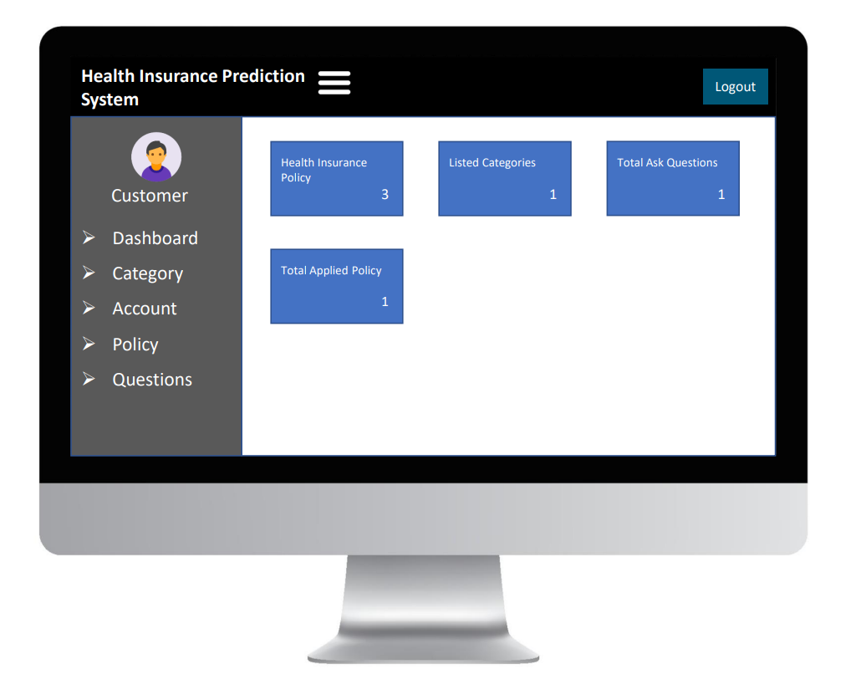

# 4.2 UI/UX Design: Manager

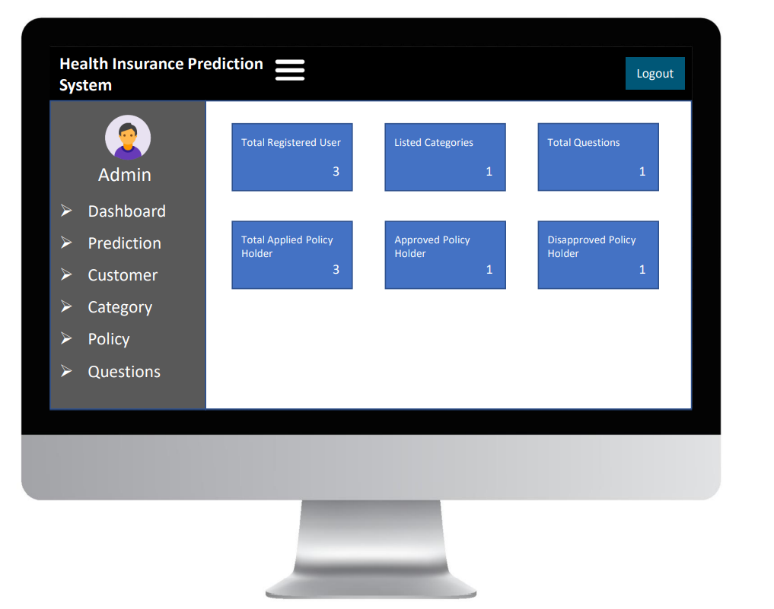

**Chapter 5**

# 5.1 Storyboard Customer

## 5.1.1 Select Location

|  |  |  |
| --- | --- | --- |
| Objects | Purpose | Validation Criteria |
| Frm.Location.C1 | This combo box will be used to select the location where customer is sitting. | Customer cannot select any location which is not available in the menu. |
| Frm.Location.B1 | Customer will click this to go to next page | In one click, the next page will be activated. |

## 5.1.2 Select Policy

|  |  |  |
| --- | --- | --- |
| Objects | Purpose | Validation Criteria |
| Frm.Policy.P1 | This box will contain policy | Customer will only write All policy picture must be available |

## 5.2 Storyboard Manager

### 5.2.1 Log In

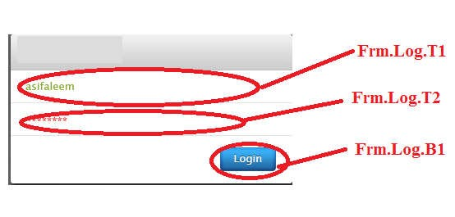

*********

admin

|  |  |  |
| --- | --- | --- |
| Objects | Purpose | Validation criteria |
| Frm.Log.T1 | In this text box manager will input his user name | No space between user name |
| Frm.Log.T2 | In this text box manager will input his user name | Password should be more than 6 characters |
| Frm.Log.B1 | If manager click this button, system will check the user name and password. After valid log in new window will open for report. | Function can be activated only in one click. |

### 5.2.2 View record

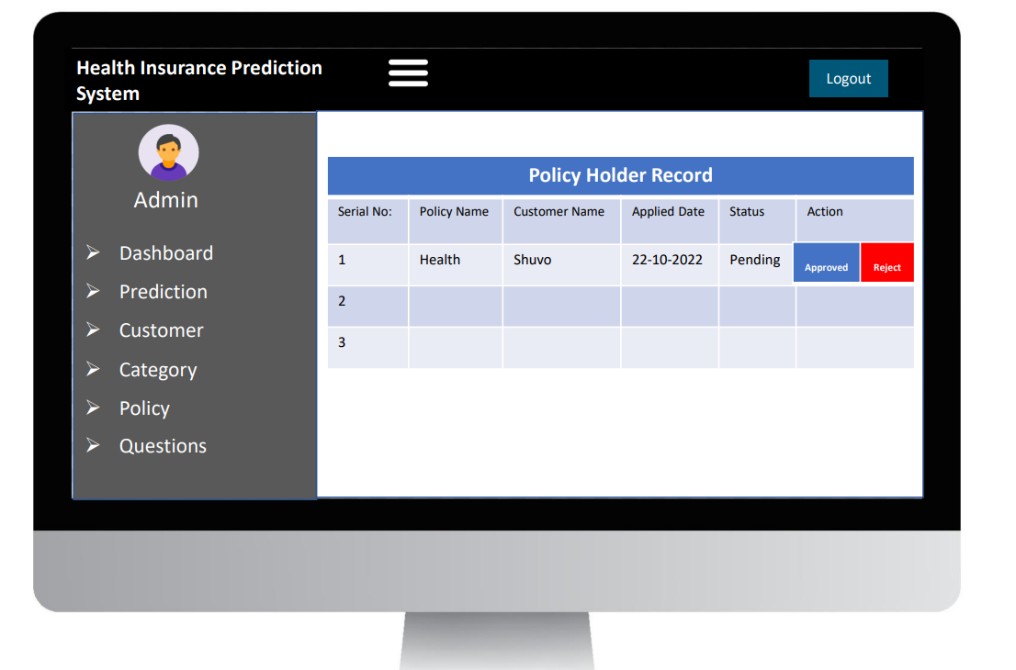

|  |  |
| --- | --- |
| Objects | Purpose |
| Rpt.all.r1 | This report will show the Name from what the customer ordered |

# 5.3. Summary

Time is our most valuable asset. We cannot waste it when there is scope of utilizing it in a better way. Our proposed system named HIS will be developed to meet this purpose. It will save the time of the mass people wasted during the time of making appointment with the managers. Along with this, HIS will also help the managers to see the previous records of a clients and they calculate easily clients Insurance. As a result, s/he can take decisions more wisely. If the client loses his/her insurance details s/he can retrieve it from the website. We hope that HIS is destined to do justice to its name.